3.75: a) ,
so the radius is R.

b) 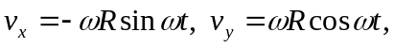
and so the dot product
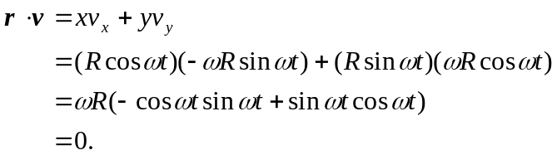

c)
and so 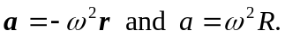

d) , and so 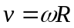.
e) 